VIRAL FUSION
NEXT THREE SLIDES — EDITOR TEMPLATE
Two Flywheels • The Moat • California: Prove It Here
EDITOR PURPOSE
These three slides finish the strategic argument after WHY MUSK? and WHY VIRAL FUSION? and hand directly into the California Go-To-Market Launch. Motion should explain causality, compounding and sequencing — not decorate the screen.

Recommended sequence:
WHY MUSK? → WHY VIRAL FUSION? → TWO FLYWHEELS → THE MOAT → CALIFORNIA: PROVE IT HERE → CALIFORNIA GO-TO-MARKET

SLIDE 3 — TWO FLYWHEELS
TECHNOLOGICAL VELOCITY + CIVIC VELOCITY
Approx. voiceover target: 1:35–1:55
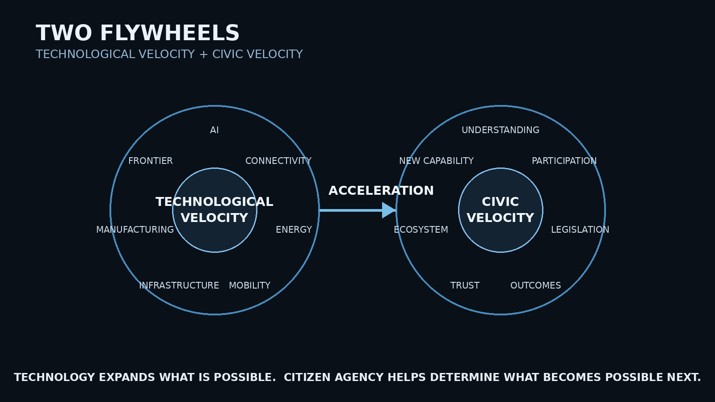
ON-SCREEN STRUCTURE
LEFT — MUSK TECHNOLOGY FLYWHEEL: AI • Connectivity • Energy • Mobility • Infrastructure • Manufacturing • Frontier
RIGHT — VIRAL FUSION CIVIC FLYWHEEL: Understanding • Participation • Legislation • Outcomes • Trust • Ecosystem • New Capability
CENTER BRIDGE: ACCELERATION
BOTTOM LINE: TECHNOLOGY EXPANDS WHAT IS POSSIBLE. CITIZEN AGENCY HELPS DETERMINE WHAT BECOMES POSSIBLE NEXT.
VOICEOVER
[NARRATOR] (Cinematic, controlled)
Now put the two architectures beside one another. On one side — a technology ecosystem built to move extraordinary capability faster. Artificial intelligence. Connectivity. Energy. Mobility. Infrastructure. Manufacturing. And access to the frontier beyond Earth. On the other — a civic architecture designed around a different form of velocity. Understanding. Participation. Lawful action. Measurable outcomes. Trust. And an ecosystem capable of turning successful outcomes into greater capability. Two different flywheels. Two different functions.
[GEORGE] (Strategic, deliberate)
Elon's companies don't need Viral Fusion to invent technology. And Viral Fusion should never need Elon Musk to tell citizens what to believe. That isn't the opportunity. The opportunity is what happens when technological capability meets a better mechanism for society to understand it — challenge it — evaluate it — and, where the public supports it, create a lawful pathway for it to move. One flywheel accelerates what humanity can build. The other accelerates our ability to decide what deserves to scale.
[NARRATOR] (Restrained; reassuring)
And importantly — neither system has to control the other. Technology remains accountable to law. Civic authority remains with citizens and lawful institutions. Independent infrastructure protects continuity. And competition determines which technologies actually perform. The objective is not concentrated control. It is coordinated acceleration without surrendering citizen sovereignty.
[GEORGE] (Building into transition)
Because when technological velocity and civic velocity begin working together, the result is not simply a faster company. It could be a faster path from problem — to solution — to proof — to deployment. And that raises the next question. If these systems begin reinforcing one another — what makes the architecture difficult to reproduce?
EDITOR / ANIMATION INSTRUCTIONS
0:00–0:15 — Begin with both flywheels visible but subdued. Activate the Musk technology flywheel node-by-node as the narrator names the capabilities.
0:15–0:30 — Activate the Viral Fusion flywheel node-by-node. Keep a clean visual gap between the two systems.
On “That isn’t the opportunity.” — HOLD. Do not connect the flywheels yet.
On “The opportunity is what happens…” — begin restrained connecting lines between corresponding functions. Suggested pairings: AI ↔ Understanding; Connectivity ↔ Participation; Infrastructure ↔ Legislation; Technology/Manufacturing ↔ Outcomes.
On “coordinated acceleration without surrendering citizen sovereignty” — both systems are fully active, but their centers remain visibly separate. Collaboration, not merger.
On “problem → solution → proof → deployment” — animate the four words in sequence across the center bridge.
Final line — dim the individual nodes and leave the connective architecture glowing. Cut directly to THE MOAT.
CRITICAL VISUAL RULE
Do not make Musk the controller of the civic flywheel. The visual must show two independent systems exchanging value. That protects the citizen-sovereignty thesis and sets up the moat as accumulated execution, not concentrated control.

SLIDE 4 — THE MOAT
ACCUMULATED EXECUTION
Approx. voiceover target: 1:20–1:40
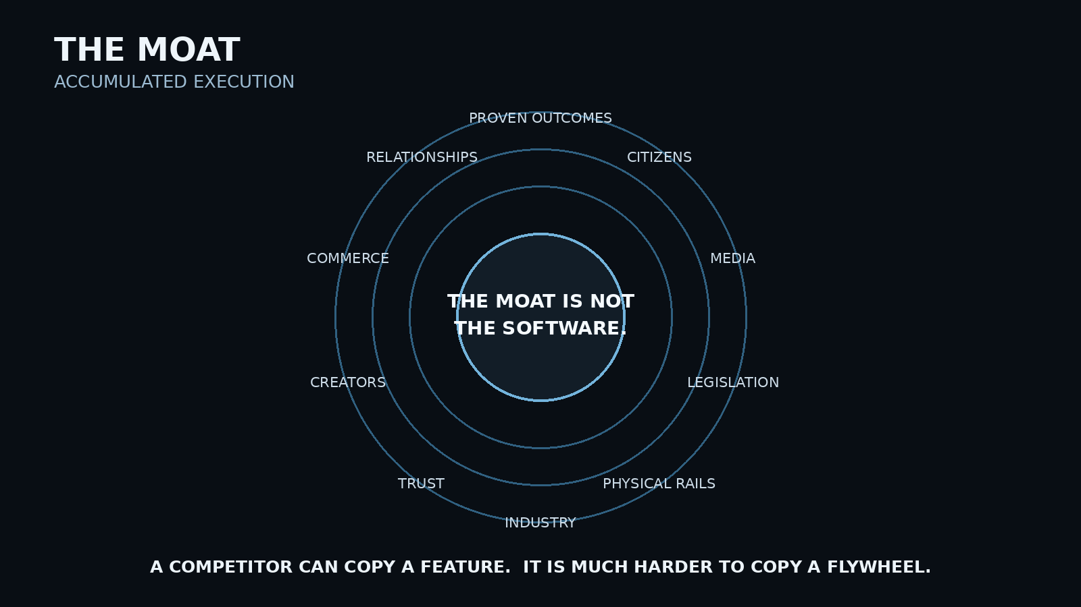
ON-SCREEN STRUCTURE
CENTER: THE MOAT IS NOT THE SOFTWARE.
SURROUNDING LAYERS: Proven Outcomes • Citizens • Media • Legislation • Physical Rails • Industry • Trust • Creators • Commerce • Relationships
BOTTOM LINE: A COMPETITOR CAN COPY A FEATURE. IT IS MUCH HARDER TO COPY A FLYWHEEL.
VOICEOVER
[NARRATOR] (Analytical; quieter)
Software can be copied. Features can be copied. Interfaces can be copied. Even business models can eventually be copied. So if Viral Fusion's advantage depends entirely on code — it does not have much of an advantage.
[GEORGE] (Executive, precise)
The potential moat is everything that accumulates around the software. Citizens who understand how to use it. Creators who know how to explain it. Physical locations capable of supporting it. Industry relationships. Technical partners. Legislative experience. Public trust. Commercial infrastructure. And most importantly — proven outcomes. Every successful action creates evidence. Every piece of evidence creates credibility. Every credible outcome makes the next conversation easier. Every new relationship expands the ecosystem. And every expansion creates capabilities a new competitor would have to rebuild from scratch.
[NARRATOR] (Measured)
That changes the nature of competition. A new platform can copy a petition feature. It cannot instantly copy the public relationships, media ecosystem, legislative history, physical footprint, institutional knowledge, commercial partners, and years of measurable civic outcomes that have accumulated around it.
[GEORGE] (Firm close)
That is why the moat is not built once. It compounds. And the same principle applies geographically. A successful launch in one state does not merely create another market. It creates knowledge, proof, content, relationships, technology, and a playbook that make the next launch more valuable than the first. So we do not begin everywhere. We earn the right to expand.
EDITOR / ANIMATION INSTRUCTIONS
Open on a near-black frame with only: THE MOAT IS NOT THE SOFTWARE.
As George names moat components, bring each element inward from the perimeter so the Viral Fusion core becomes progressively surrounded by reinforcing layers.
On “proven outcomes” — make that layer the strongest visual emphasis. Outcomes are the deepest moat because they create evidence and credibility.
On “A new platform can copy a petition feature” — briefly isolate one simple software tile while the larger ecosystem fades back.
On “It cannot instantly copy…” — pull back and reveal the full architecture again.
On “It compounds.” — expand the layers outward subtly, suggesting accumulated history and relationships.
Final beat: clear the screen down to WE EARN THE RIGHT TO EXPAND. Hold 1–2 seconds before California appears.
EDITOR INTENT
This slide should feel defensive in a business-strategy sense, not militaristic. The audience should understand that the moat is accumulated trust, execution, outcomes, relationships and physical/digital infrastructure — not artificial lock-in.

SLIDE 5 — CALIFORNIA
PROVE IT HERE.
Approx. voiceover target: 1:25–1:45
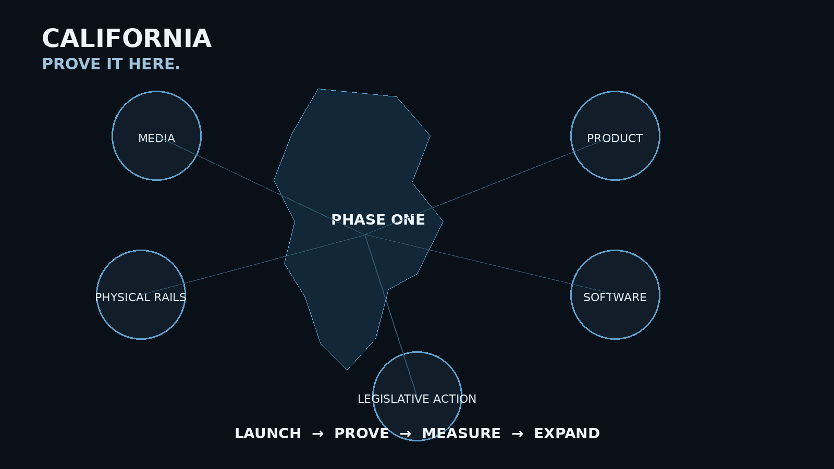
ON-SCREEN STRUCTURE
PHASE ONE — CALIFORNIA
Activation points: MEDIA • PRODUCT • PHYSICAL RAILS • SOFTWARE • LEGISLATIVE ACTION
PROCESS: LAUNCH → PROVE → MEASURE → EXPAND
BOTTOM LINE: NOT NATIONAL ON DAY ONE. NATIONAL BY EARNING DEMAND.
VOICEOVER
[NARRATOR] (Grounded; execution-focused)
And that is why Viral Fusion does not begin by trying to launch everywhere. It begins in California. Not because California is easy — but because it gives us a demanding environment in which to test whether the architecture works across technology, media, industry, public policy, infrastructure, and citizen participation.
[GEORGE] (Controlled momentum)
California is not the finish line. It is the proving ground. We launch the ecosystem. We activate the media rails. We introduce the first physical products. We bring creators into the economic model. We begin onboarding physical locations. We launch the software. And then — we put the architecture under pressure. Real issues. Real legislation. Real signatures. Real voters. Real outcomes.
[NARRATOR] (Measured)
Because the first objective is not national scale. It is proof. Can Viral Fusion create public understanding? Organize lawful participation? Help qualify meaningful measures? Help citizens evaluate competing arguments? And produce outcomes people can actually measure? If it can — California becomes more than the first market. It becomes the evidence.
[GEORGE] (Strong, restrained)
And evidence creates demand. Another state sees what happened. Another group of citizens asks for access. Another creator network forms. Another physical network becomes possible. Another legislative opportunity enters the architecture. And the flywheel turns again — but faster, because the second launch begins with everything the first one taught us. That is how we scale. Not by opening every door at once. By proving enough value that people begin asking us to open the next one.
EDITOR / ANIMATION INSTRUCTIONS
Open with a faint outline of the United States. Keep every state subdued except California.
On “It begins in California.” — illuminate California and remove unnecessary national detail.
On “We launch the ecosystem” — activate the California core.
As George names Media / Products / Creators / Physical Locations / Software — introduce those nodes one at a time. Do NOT reveal the actual two launch products yet; save them for the California Go-To-Market chapter.
On “Real issues. Real legislation. Real signatures. Real voters. Real outcomes.” — reveal each phrase sequentially. Hold OUTCOMES slightly longer.
On “California becomes… the evidence.” — visually transform California from an active launch node into a completed/proven node or subtle proof mark.
Then reveal several dim, unnamed nodes elsewhere in the U.S. Do not identify State #2 yet.
On “people begin asking us to open the next one” — allow one unnamed state node to pulse once. Cut before naming it.
HANDOFF TO NEXT CHAPTER
End this slide with anticipation, not explanation. The audience should now ask: “What exactly launches in California?” The next chapter answers that with the California Go-To-Market Launch, including the two physical products, creator/affiliate activation, media rails, software launch and legislative rollout.

JEETU — THREE-SLIDE EDITING SUMMARY
Slide | Core Question | Visual Job | Transition
3 — Two Flywheels | What happens when technological and civic velocity connect? | Show two independent systems exchanging value. | “What makes this hard to reproduce?”
4 — The Moat | Why can’t this simply be copied? | Reveal accumulated execution around the software. | “We earn the right to expand.”
5 — California | Where do we prove the model? | Turn strategy into a concrete Phase One geography. | “What exactly launches in California?”
Overall motion philosophy: build → connect → compound → prove. Every animation should communicate one of those four ideas.

